**ASSIGNMENT NO. 01**

**Name – Atharva Shivaji Jadhav Roll Number - DXC262AB12035**

**Batch – Dxc-262-Analytics-B12-Azure Company – DXC Technology**

**Employee Domain –Azure Analytics Training Under – Manipal Pro Learn**

***CASE 1:***

CREATE TABLE globetechtb231(emp_id INT NOT NULL, emp_name varchar(255) NOT NULL,

job_name varchar(255) NOT NULL, manager_id int, hire_date date NOT NULL, salary INT NOT NULL,

commission INT , dep_id int NOT NULL, constraint pk_globaltechtb231 primary key(emp_id));

INSERT INTO

globetechtb231(emp_id,emp_name,job_name,manager_id,hire_date,salary,commission,dep_id)

values(68319, 'KAYLING', 'PRESIDENT',NULL ,to_date('1991-11-18','yyyy-mm-dd'),6000.00,NULL,

1001);

INSERT INTO

globetechtb231(emp_id,emp_name,job_name,manager_id,hire_date,salary,commission,dep_id)

values(66928, 'BLAZE', 'MANAGER',68319 ,to_date('1991-05-01','yyyy-mm-dd'),2750.00,NULL, 3001);

INSERT INTO

globetechtb231(emp_id,emp_name,job_name,manager_id,hire_date,salary,commission,dep_id)

values(67832, 'CLARE', 'MANAGER',68319 ,to_date('1991-06-09','yyyy-mm-dd'),2550.00,NULL,

1001);

INSERT INTO

globetechtb231(emp_id,emp_name,job_name,manager_id,hire_date,salary,commission,dep_id)

values(65646, 'JONAS', 'MANAGER', 68319 ,to_date('1991-04-02','yyyy-mm-dd'),2957.00,NULL,

2001);

INSERT INTO

globetechtb231(emp_id,emp_name,job_name,manager_id,hire_date,salary,commission,dep_id)

values(67858, 'SCARLET', 'ANALYST', 65646 ,to_date('1997-04-19','yyyy-mm-dd'),3100.00,NULL,

2001);

INSERT INTO

globetechtb231(emp_id,emp_name,job_name,manager_id,hire_date,salary,commission,dep_id)

values(69062, 'FRANK', 'ANALYST',65646 ,to_date('1991-12-03','yyyy-mm-dd'),3100.00,NULL, 2001);

INSERT INTO

globetechtb231(emp_id,emp_name,job_name,manager_id,hire_date,salary,commission,dep_id)

values(63679, 'SANDRINE', 'CLERK', 69062 ,to_date('1990-12-18','yyyy-mm-dd'),900.00,NULL, 2001);

INSERT INTO

globetechtb231(emp_id,emp_name,job_name,manager_id,hire_date,salary,commission,dep_id)

values(64989, 'ADELYN', 'SALESMAN',66928 ,to_date('1991-02-20','yyyy-mm-dd'),1700.00,400,

3001);

INSERT INTO

globetechtb231(emp_id,emp_name,job_name,manager_id,hire_date,salary,commission,dep_id)

values(65271, 'WADE', 'SALESMAN',66928 ,to_date('1991-02-22','yyyy-mm-dd'),1350.00,600, 3001);

INSERT INTO

globetechtb231(emp_id,emp_name,job_name,manager_id,hire_date,salary,commission,dep_id)

values(66564, 'MADDEN', 'SALESMAN',66928 ,to_date('1991-09-28','yyyy-mm-dd'),1350.00,1500,

3001);

INSERT INTO

globetechtb231(emp_id,emp_name,job_name,manager_id,hire_date,salary,commission,dep_id)

values(68454, 'TUCKER', 'SALESMAN',66928 ,to_date('1991-09-08','yyyy-mm-dd'),1600.00,0, 3001);

INSERT INTO

globetechtb231(emp_id,emp_name,job_name,manager_id,hire_date,salary,commission,dep_id)

values(68736, 'ANDRES', 'CLERK',67858 ,to_date('1997-05-23','yyyy-mm-dd'),1200.00, NULL , 2001);

INSERT INTO

globetechtb231(emp_id,emp_name,job_name,manager_id,hire_date,salary,commission,dep_id)

values(69000, 'JULIUS', 'CLERK',66928 ,to_date('1991-12-03','yyyy-mm-dd'),1050.00,NULL, 3001);

INSERT INTO

globetechtb231(emp_id,emp_name,job_name,manager_id,hire_date,salary,commission,dep_id)

values(69324, 'MARKER', 'CLERK',67832 ,to_date('1992-01-23','yyyy-mm-dd'),1400.00,NULL, 1001);

select * from globetechtb231

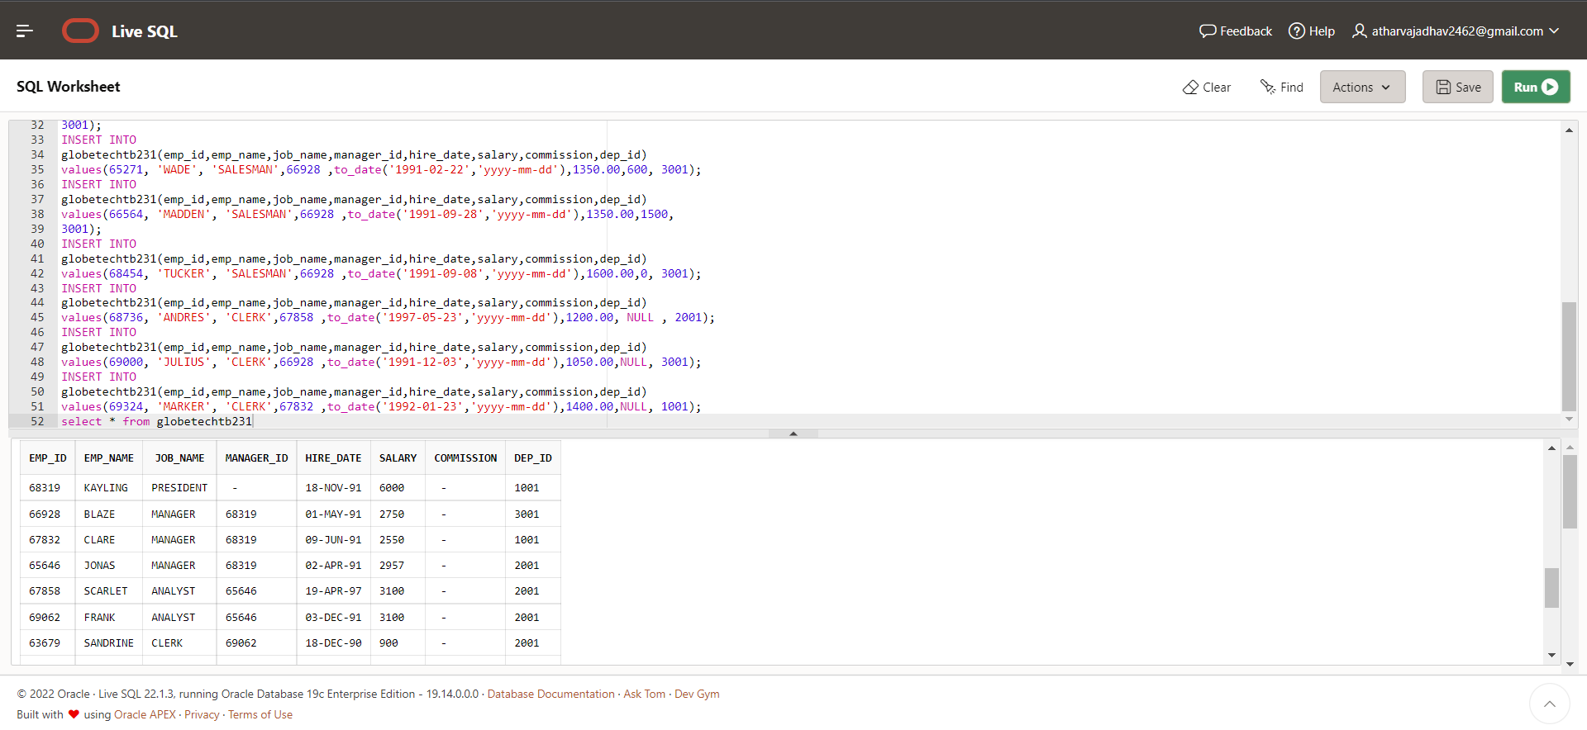

CASE 2:

***SELECT salary from globetechtb231;***

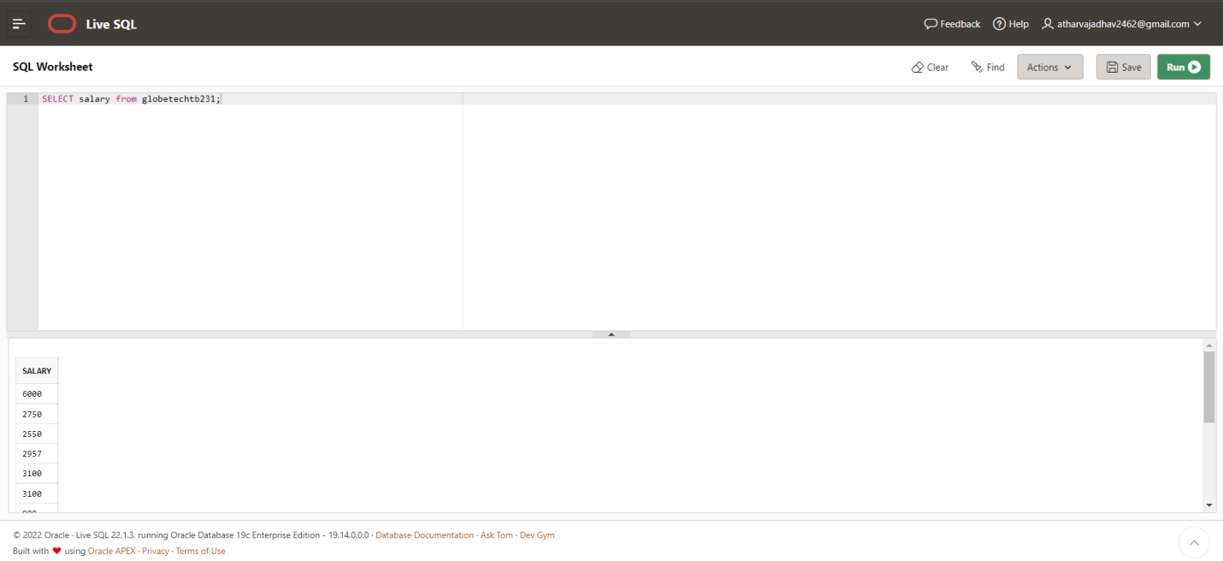

CASE 3:

***SELECT DISTINCT(job_name) from globetechtb231;***

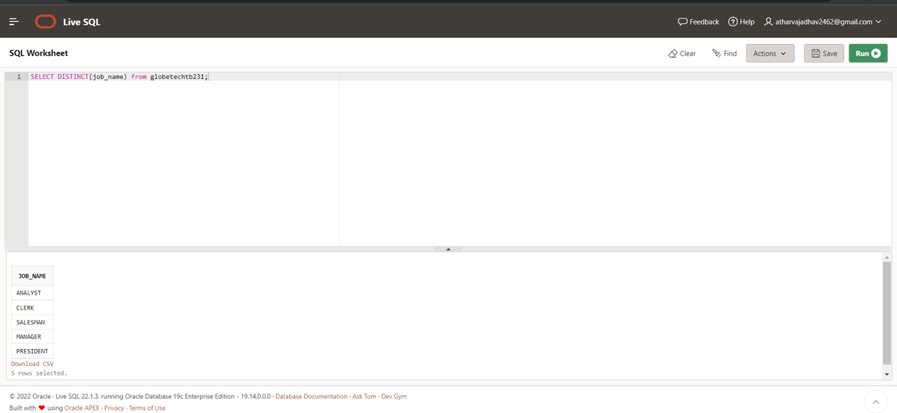

CASE 4:

***SELECT emp_name, to_char(1.15*salary,'$99,999') AS "Salary" from globetechtb231;***

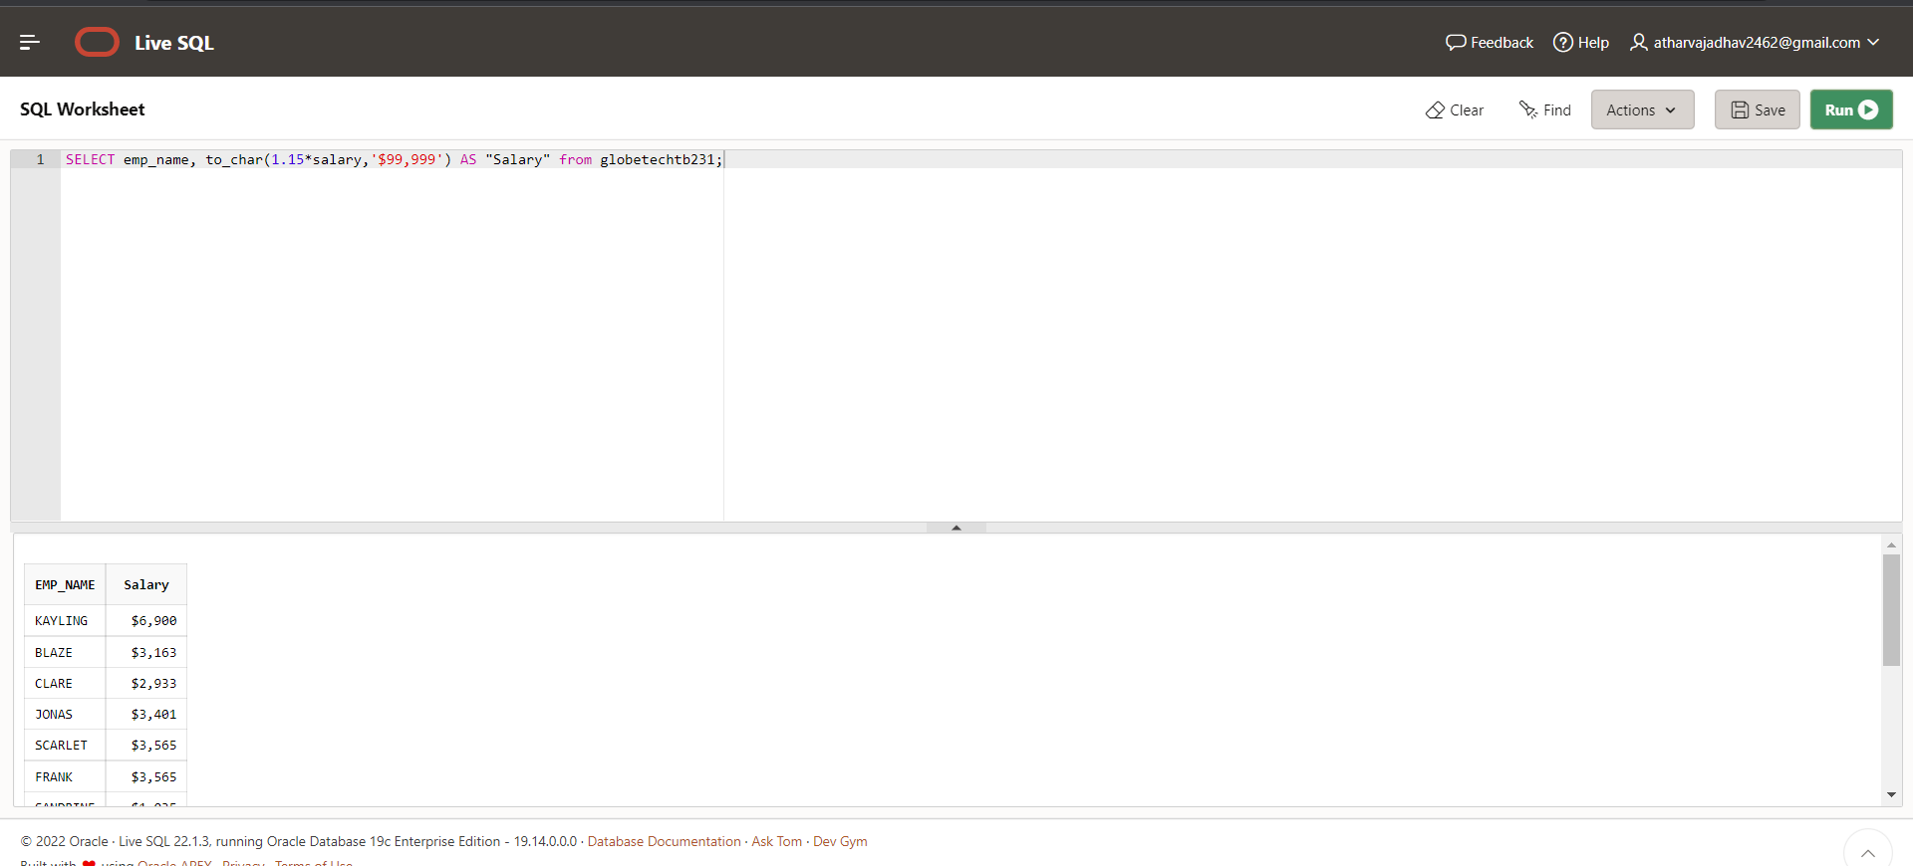

CASE 5:

***SELECT emp_name||' '||job_name AS "Employee & Job" FROM globetechtb231;***

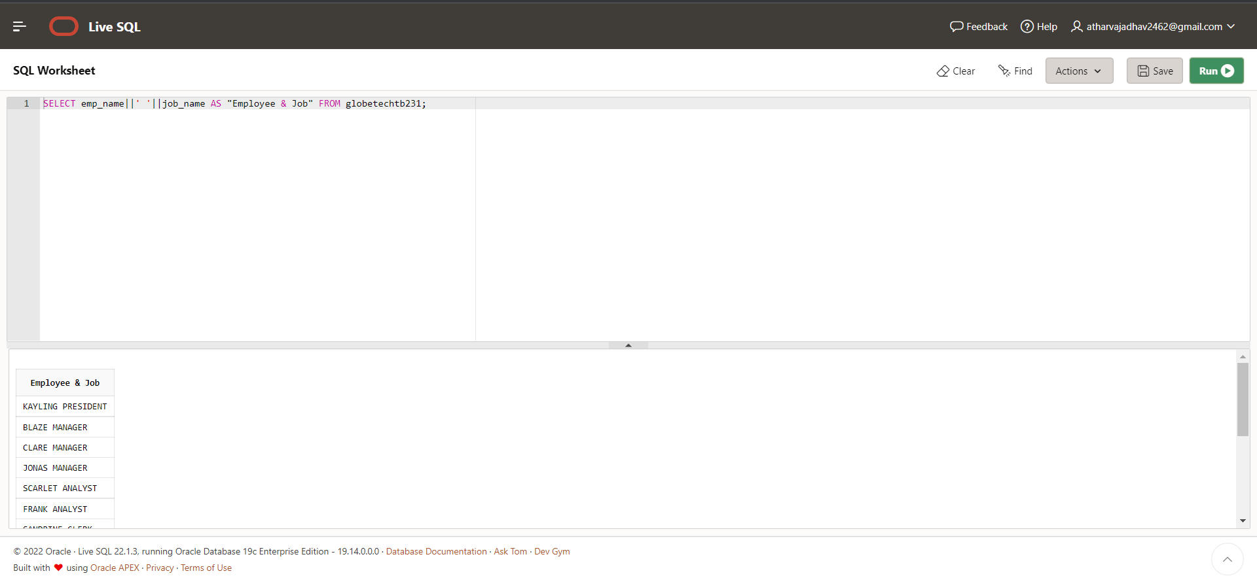

CASE 6:

***SELECT emp_name || '('|| lower(job_name)||')' AS "Employee" FROM globetechtb231;***

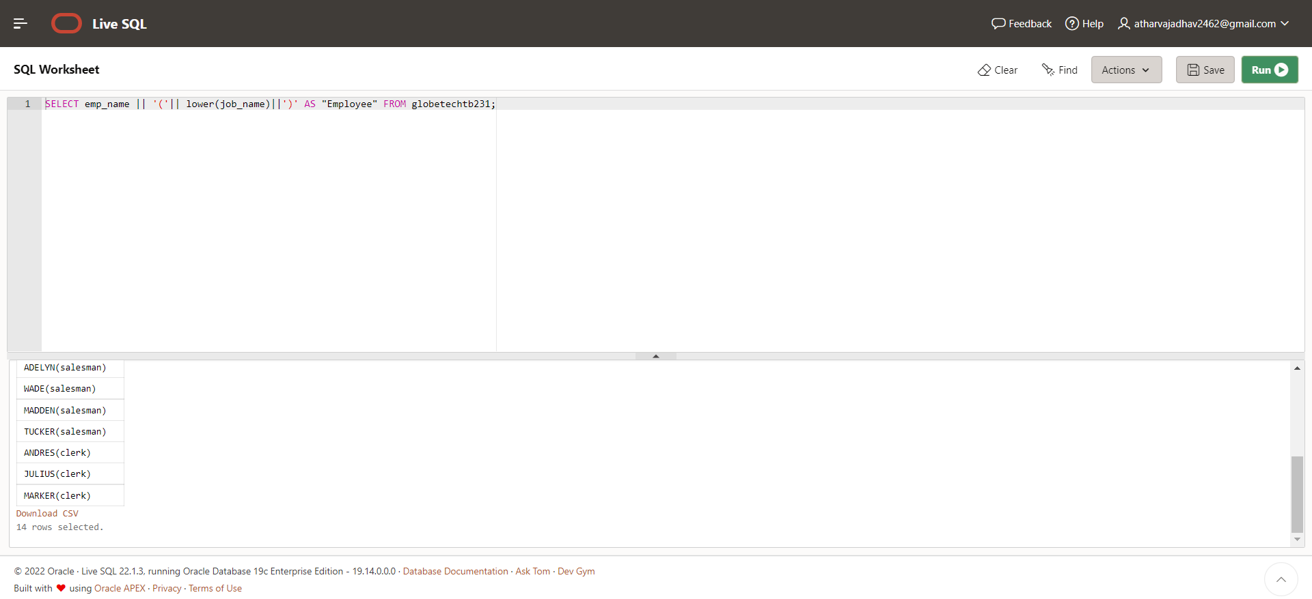

CASE 7:

***SELECT emp_id,***

***emp_name,***

***salary,***

***to_char(hire_date,'MONTH DD,YYYY')***

***FROM globetechtb231;***

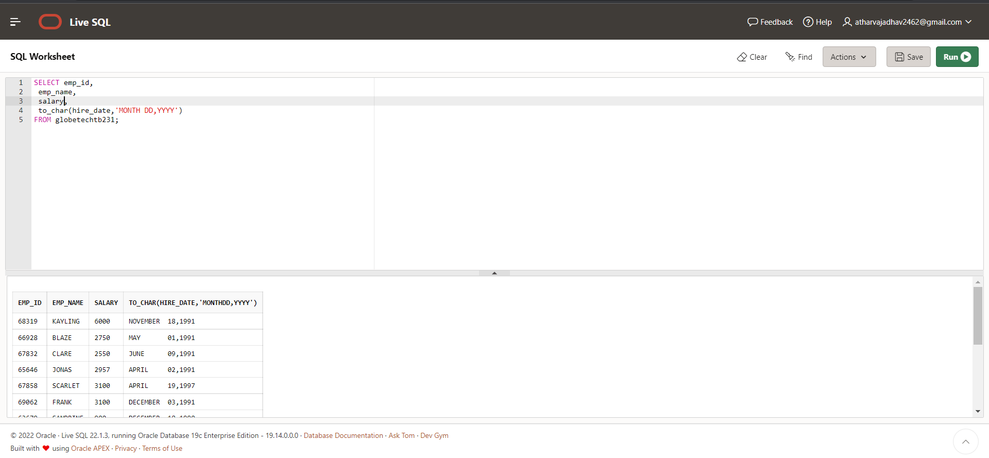

CASE 8:

***SELECT length(trim(emp_name)) FROM globetechtb231;***

